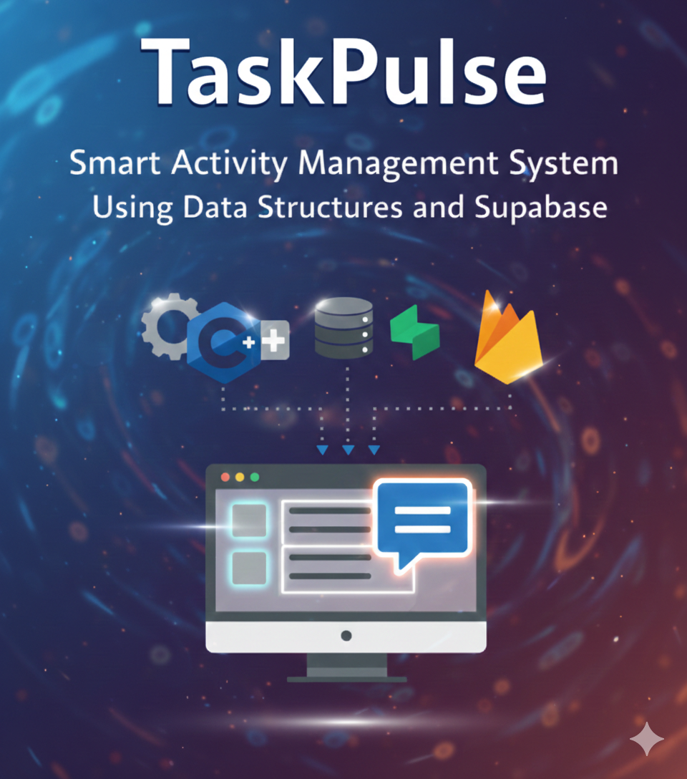

NO | NAMES OF THE MEMEBERS
01 | MUHAMMAD IRTIZA KHAN
02 | SAAD PERVAIZ
03 | ALI QAQOOB KHAN
Member | Research | DSA Implementation | Frontend | Backend | Database | System Architecture | Language Selection
Muhammad Irtiza Khan | 58% | 47% | 45% | 76% | 33% | 40% | 56%
Ali yaqoob | 5% | 30% | 30% | 8% | 4% | 20% | 11%
Saad Pervaiz | 37% | 23% | 25% | 16% | 25% | 40% | 33%

Projects details section :
PROJECT-NAME : TASKPULSE
PROJECT-MOTIVE: Smart Activity Management System using Data Structures and Supabase
PROJECT-TARGET: The primary target of Task Pulse is to develop an integrated task and activity management system that combines modern web technologies with core data structure concepts to demonstrate practical implementation of computer science fundamentals.
Project Idea (Detailed Explanation):
Task Pulse is a full-stack task management system that integrates a frontend interface, a backend server, a database, and a C++-based data structures layer.
The core objective of this project is to enable real-time task and activity handling, combined with efficient data organization, by leveraging modern web technologies alongside fundamental data structures concepts.
Problem Statement:
Most student projects rely completely on databases and perform only basic CRUD operations. Such projects fail to demonstrate the role of Data Structures in managing data efficiently.
TaskPulse solves this problem by:
- Using Supabase for persistent storage
- Using Vectors and Stacks for operational logic
- Clearly separating what the database does and what DSA does
CRUD OPERATIONS ?
ans: CRUD operations are the four basic functions for managing data in a database or application:
objectives of the project :
- To integrate Supabase database with a DSA-based backend
- To apply C++ vectors for managing activity records in memory
- To implement Undo and Redo functionality using stacks
- To demonstrate how databases and data structures work together
- To build a scalable and modular system architecture

Key Features of TaskPulse
- Add activities dynamically
- Real-time C++ backend processing
- Undo last performed activity
- Redo undone activities
- Efficient in-memory data handling
- Modern and user-friendly UI
Uniqueness of TaskPulse:
- Uses C++ as a live backend engine
- Focuses on DSA rather than database dependency
- Implements real undo/redo logic
- Integrates low-level programming with web technologies

Educational Importance
TaskPulse helps students understand:
- Practical use of vectors and stacks
- Real-world undo/redo/add/delete/update implementation
- Backend architecture and communication
- Importance of data structures in system design

Technologies Used
Frontend
- HTML
- CSS
- JavaScript
- Firebase for authentication
Backend
- Node.js
- Express.js
Database
- Supabase (PostgreSQL-based)
DSA Layer
- C++
- Vector
- Stack
Data Exchange
- JSON format

System Architecture (Conceptual)
TaskPulse follows a multi-layer architecture:
- Frontend Layer
  - Collects user activity data
  - Sends data to backend in JSON format
- Server Layer (Node.js)
  - Receives frontend requests
  - Communicates with Supabase
  - Forwards data to C++ DSA engine
- DSA Processing Layer (C++)
  - Uses vector and stacks to perform the features present in the web app
  - Applies logic before or after database updates
- Database Layer (Supabase)
  - Stores final activity records permanently
  - Maintains structured tables and fields
Workflow of TaskPulse
- User enters activity details on the frontend
- Data is sent to the backend server
- Backend:
  - Stores activity in Supabase
  - Sends activity data to C++ engine
- C++ engine:
  - Pushes activity into a vector and stacks
  - Perform the actions according to user choiuce if the feature
- Backend confirms successful operation to frontend
This ensures DSA logic + database storage both remain synchronized.

Data structures and algorithm:

1.VECTOR — vector<Activity> activities
Use: Main storage for all activities
Feature:
- Base storage for CRUD operations
- Display all activities
- Works like a dynamic array (fast access, iteration)

2. STACK — stack<Activity> undoStack
Use: Stores recently deleted activities
Feature:
- Undo Delete – Restore the last deleted activity
- LIFO (Last In First Out) – Last deleted item is undone first

3. STACK — stack<Activity> redoStack
Use: Stores undone activities for redo operation
Feature:
- Redo Delete – Re-apply a previously undone deletion
- Opposite operation of Undo

4. stack<pair<Activity, Activity>> updateUndoStack
Use: Stores both old and new values before an update operation
Feature:
- Undo Update – Revert an activity back to its previous state
- Stores pair as (oldActivity, newActivity)

5. STACK — stack<Activity> permanentDeleteStack
Use: Maintains a record of permanently deleted activities (logging only)
Feature:
- Permanent Delete Logging – Tracks which activity was permanently deleted
- Cannot be recovered – stored only for display/record purposes

Why built data structures are used instead of manual
Use what’s already built, tested, and optimized — save time, save memory, save effort."

Reason | Explanation
Saves Time | Writing custom data structures takes hours — STL is ready to use
Memory Safe | STL manages memory automatically (no new/delete, no memory leaks)
Optimized | STL is decades old and highly optimized — better than writing from scratch
Bug Free | STL is tested by millions of developers — no need to reinvent
Readable | Any developer can understand STL instantly
Maintainable | Less code = easier to debug and upgrade
Focus | We focus on project logic, not building basic data structures

(DATA STRUCTURE ) use in this project :
Following are the data structures alghorithm that implement in task pulse :
Data Structure | Why Used? | Time Complexity | Space Complexity | Real-World Reason
vector<Activity> | Dynamic array, fast access, cache-friendly | O(1) access, O(n) search, O(1) push_back | O(n) | Fast iteration, simple CRUD, contiguous memory
stack<Activity> | LIFO behavior for undo/redo | O(1) push/pop/top | O(n) | Last deleted is undone first — exact LIFO needed
stack<pair<Activity, Activity>> | Stores old + new value for undo update | O(1) push/pop | O(n) | Needed to store two values together (old + new)

PHASES OF THE PROJECT:
STAGE 01:
Research carried out about in order to test even if the idea we will be going to work on is possible at all or not
Reseach sources: research via project folder on chatgpt ,deepseek
Research duration: 12 days
Research link: https://chatgpt.com/share/698e3f2f-fdec-8013-bdee-8656d7679488

Stage no 02:
Testing phase :
Frontend Testing
- Verified all pages load correctly:
  - Landing Page
  - LOGIN/Register Page
  - User Interface
- Checked form validation
- Confirmed button click events (Add Activity)

API Testing
- Tested /api/add-activity endpoint
- Verified JSON data is correctly sent from frontend
- Checked server responses using console & terminal logs

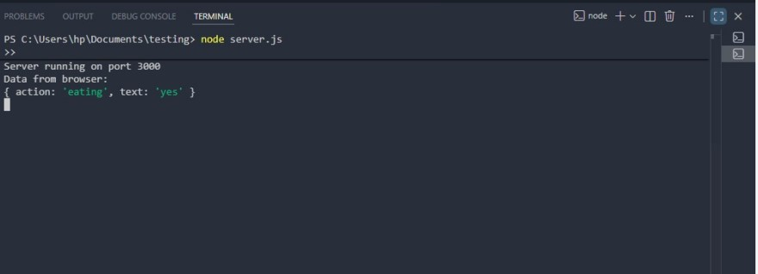
Backend Server Testing
Confirmed Node.js server runs on defined port
- Verified static files serving
- Ensured server does not crash on multiple requests
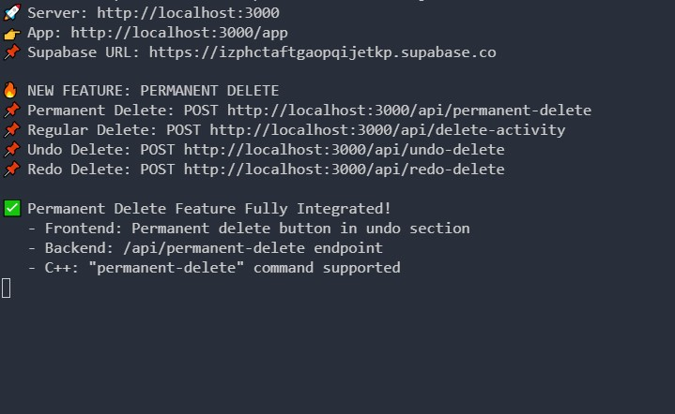
C++ Integration Testing
- Verified C++ executable receives data from server
- Confirmed:
  - Activities added into vector ( ALL ACTIONS OF THE PROJECT LIKE UPDATE, DELETE,ADD,UNDO ,REDO )
  - Stack operations work as expected
- Terminal output matches frontend input

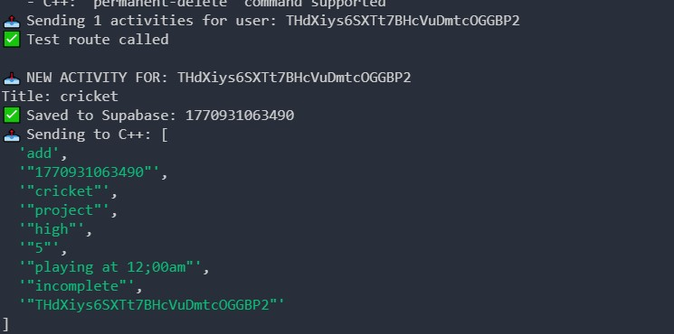

Protypes (intial phases of designing app) or workflows:
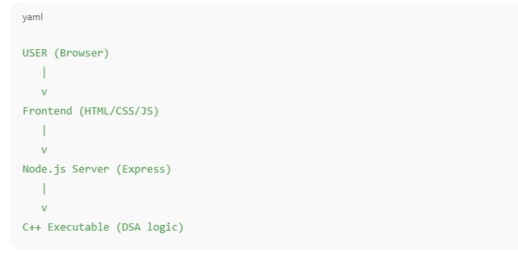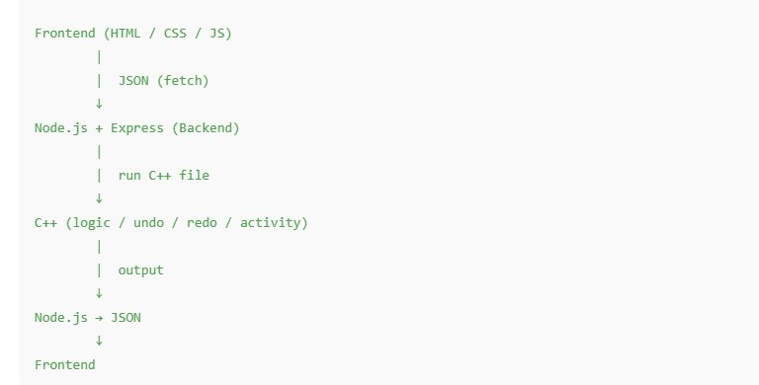

Workflow diagram :
Demonstrates how data is flowing all over application
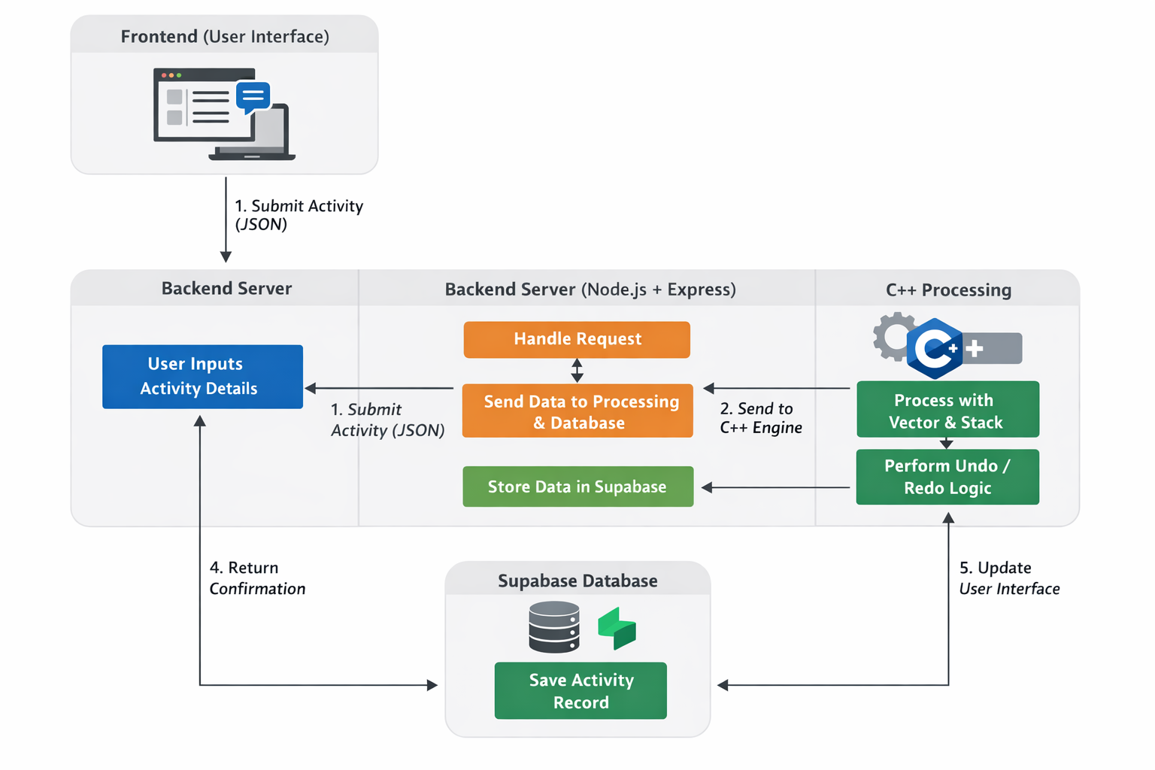
The workflow diagram represents the complete data flow of the Task Pulse application, showing how information moves across different layers of the system.
The architecture is divided into four main components:
- Frontend (User Interface)
- Backend Server (Node.js + Express)
- C++ Processing Layer (Vector & Stack)
- Supabase Database

Step 1: User Interaction (Frontend Layer)
The process begins at the Frontend, where the user enters activity details through the web interface.
- When the user clicks the “Submit Activity” button,
- The data is converted into JSON format,
- And sent to the backend server via an HTTP request.
This represents the first flow of data from the client side to the server.
Step 2: Request Handling (Backend Server)
The Node.js + Express backend server receives the incoming request.
At this stage, the server performs two important operations:
- It forwards the activity data to the C++ processing engine.
- It prepares the data to be stored in the Supabase database.
The backend acts as the central controller that connects all layers of the system.

Step 3: C++ Data Processing (Vector & Stack Logic)
The C++ engine processes the received activity data.
Inside this layer:
- The activity is stored temporarily in a vector (dynamic in-memory storage).
- Stack operations are applied for logical handling (such as undo/redo functionality).
- The processing result is generated and returned to the backend.
This layer demonstrates the practical implementation of Data Structures within the application.
Step 4: Database Storage (Supabase Layer)
Simultaneously, the backend stores the activity in the Supabase database.
- The activity record is saved permanently.
- This ensures persistence even if the server restarts.
- The database maintains structured records of all activities.

Step 5: Response & UI Update
After successful processing and storage:
- The backend sends a confirmation response to the frontend.
- The user interface updates accordingly.
- The user receives feedback that the activity has been successfully added.
This completes the full cycle of data flow.

Overall Data Flow Summary
The diagram clearly illustrates that:
Frontend → Backend → (C++ Processing + Supabase Storage) → Backend → Frontend
This layered architecture ensures:
- Separation of concerns
- Efficient logical processing
- Secure data storage
- Real-time interaction
Justification
The workflow proves that Task Pulse:
- Integrates web technologies with core C++ data structures
- Uses vector and stack in a real processing environment
- Separates storage (database) from logic (DSA layer)
- Demonstrates complete end-to-end system design
LIMITATIONS OF TASK PULSE
Although Task Pulse successfully integrates frontend, backend, database, and a C++ DSA engine, the system currently has the following limitations:
- Not Deployed on Cloud
The application is currently running in a local development environment and has not yet been deployed on a cloud platform such as AWS or VPS.

Future deployment plan:
In the future, Task Pulse can be deployed on cloud platforms such as AWS, Render, or DigitalOcean. The backend server can be hosted as a cloud service, and the C++ engine can be containerized using Docker for better scalability and portability.
CONCLUSION
Task Pulse successfully demonstrates the practical integration of Data Structures and modern web technologies in a real-world application. The project combines a structured frontend, a Node.js backend server, Supabase for persistent storage, Firebase for user management, and a C++ processing engine that implements core data structures such as vectors and stacks.
The system proves that Data Structures are not limited to theoretical problems but can be effectively applied in full-stack applications. By separating logical processing (C++ DSA layer) from database storage (Supabase) and authentication (Firebase), the application follows a clean multi-layer architecture.
The implementation of vector-based storage and stack-based undo/redo operations highlights efficient data management techniques. The real-time communication between frontend, backend, database, and C++ engine demonstrates strong understanding of system design and backend architecture.
Overall, Task Pulse bridges the gap between academic DSA concepts and practical software engineering. The project strengthens understanding of algorithmic thinking, modular system design, and real-time data processing, making it both technically sound and academically valuable.

